TASK:6

Solve a Map Coloring problem using constraint satisfaction approach by applying following constraints
Aim: To Solve a Map Coloring problem using constraint satisfaction approach using Graphonline and visualago online simulator.

Algorithm:
Step 1: Confirm whether it is valid to color the current vertex worth the current color (by checking whether any of its adjacent vertices are colored with the same color)
Step 2: If yes then color it and otherwise try a different color
Step 3: check if all vertices are colored or not
Step 4: If not then move to the next adjacent uncolored vertex
Step 5: Here backtracking means to stop further recursive calls on adjacent vertices.

PROGRAM
class Graph:
def __init__(self, vertices):
self.v = vertices
self.graph = [[0 for column in range(vertices)] for row in range(vertices)]

# A utility function to check if the current color assignment is safe for vertex v
def is_safe(self, v, color, c):
for i in range(self.v):
if self.graph[v][i] == 1 and color[i] == c:
return False
return True

# A recursive utility function to solve m-coloring problem
def graph_color_util(self, m, color, v):
if v == self.v:
return True
for c in range(1, m + 1):
if self.is_safe(v, color, c):
color[v] = c
if self.graph_color_util(m, color, v + 1):
return True
color[v] = 0
return False

def graph_coloring(self, m):
color = [0] * self.v
if not self.graph_color_util(m, color, 0):
print("Solution does not exist with", m, "colors")
return False

print("Solution exists and following are the assigned colors:")
for idx, c in enumerate(color):
print(f"Vertex {idx} -> Color {c}")
return True

# Driver Code
if __name__ == '__main__':
g = Graph(4) # 4 vertices

g.graph = [
[0, 1, 0, 1],
[1, 0, 1, 0],
[0, 1, 0, 1],
[1, 0, 1, 0]
]

m = 3 # number of colors
g.graph_coloring(m)

OUTPUT
Solution exists and following are the assigned colors:
Vertex 0 -> Color 1
Vertex 1 -> Color 2
Vertex 2 -> Color 1
Vertex 3 -> Color 2

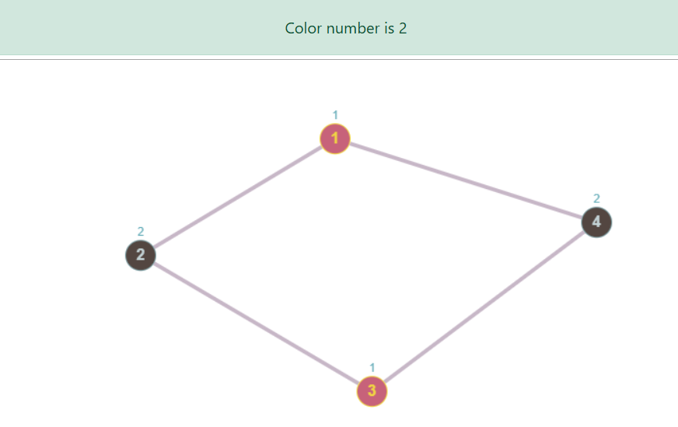

RESULT
Thus solving a Map coloring problem using constraints satisfaction approach is successfully executed

